**Session 1**

1. Create a class name Demo, create a file.

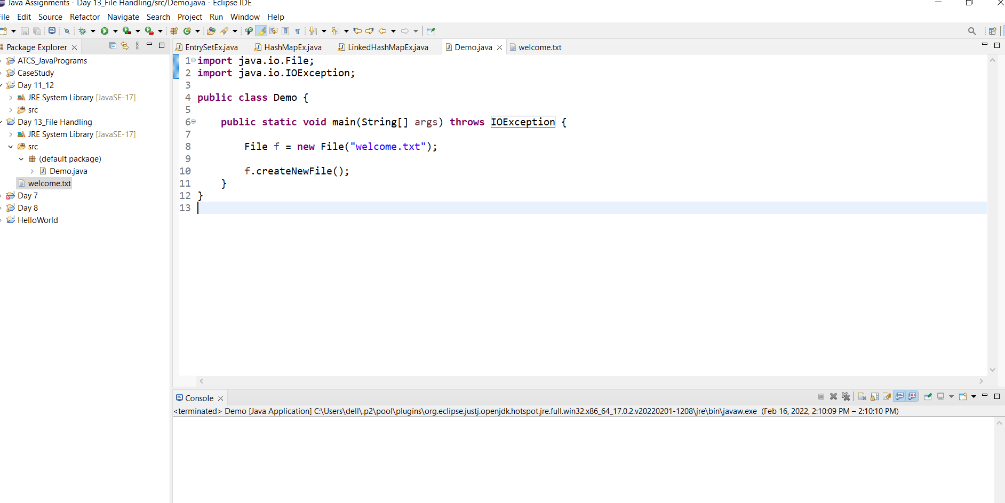

1. create a class and add file and folder into the project.



1. create a class and write the information by using File Writer.

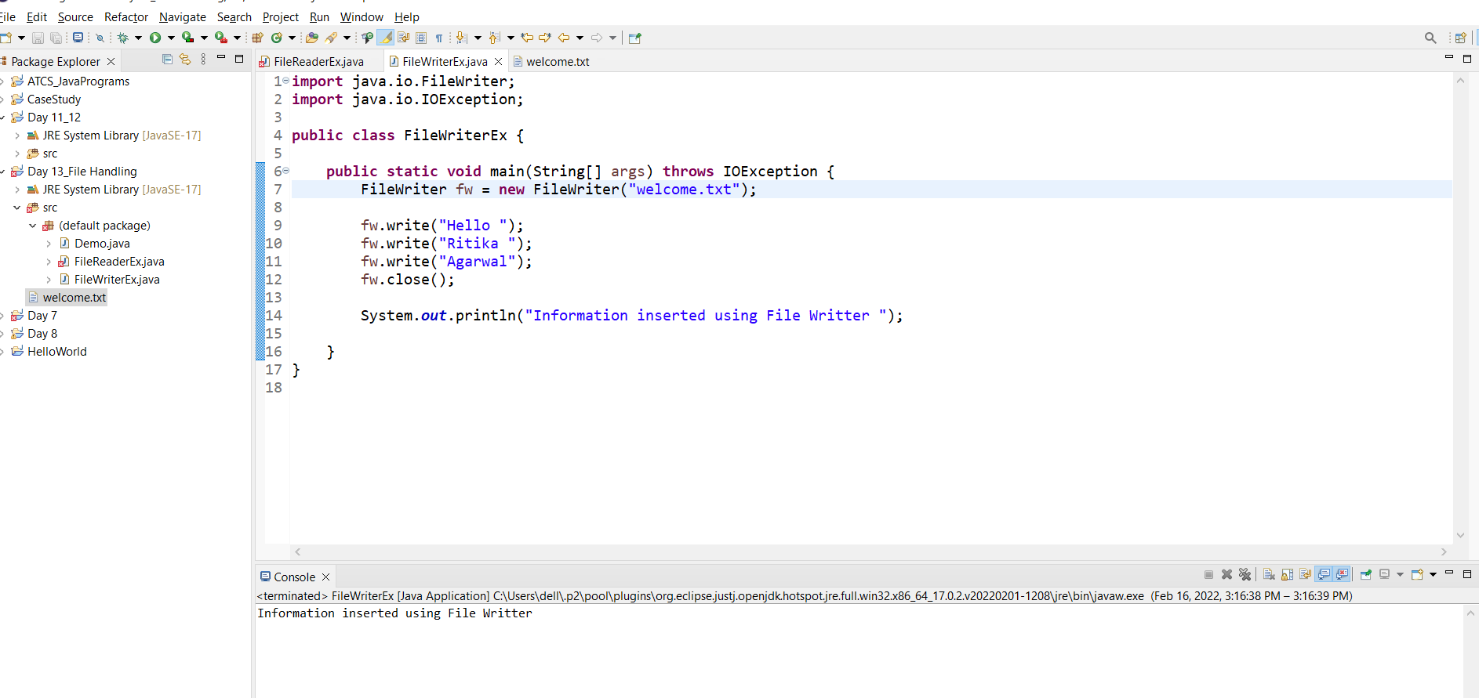

Welcome file output:

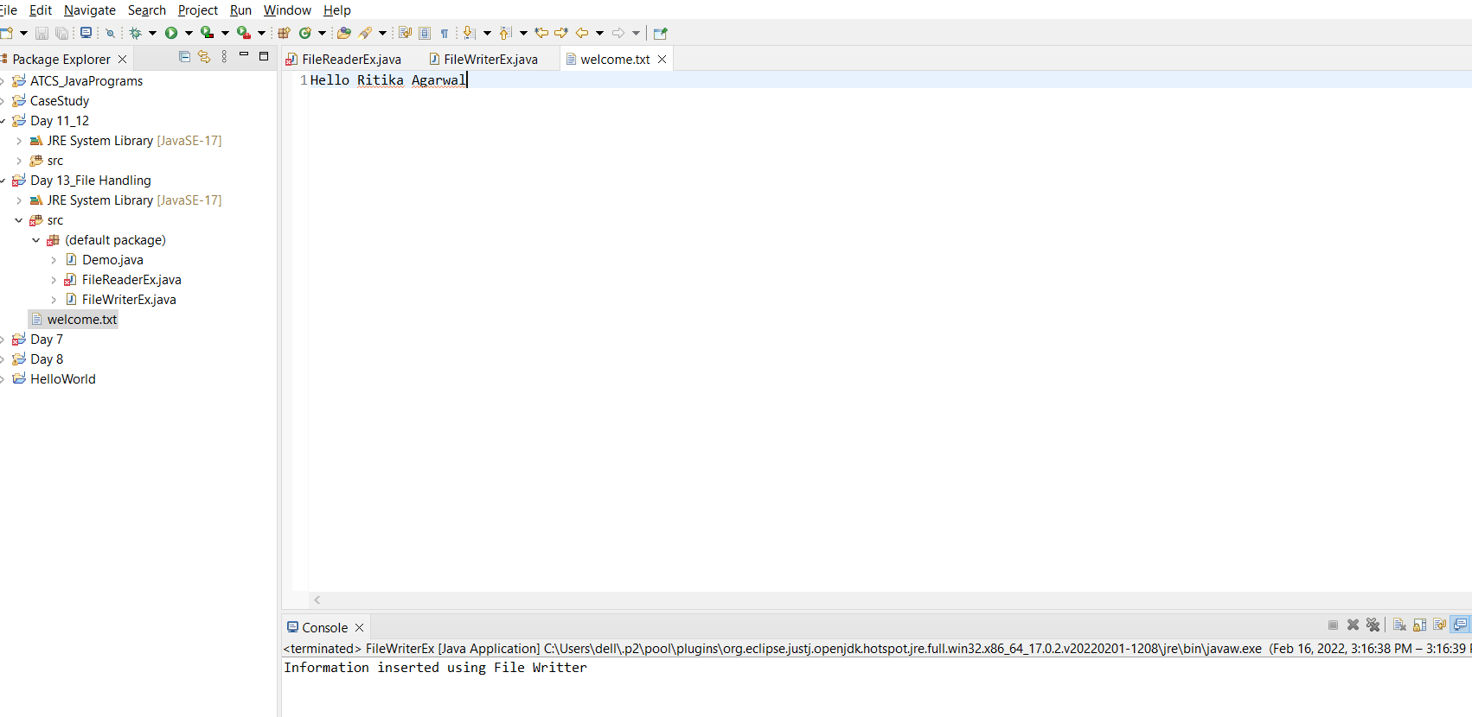

1. create a class and write the information by using Buffered Writer.

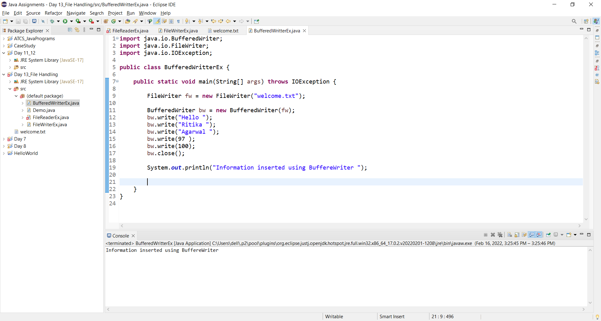

Welcome.txt file output:

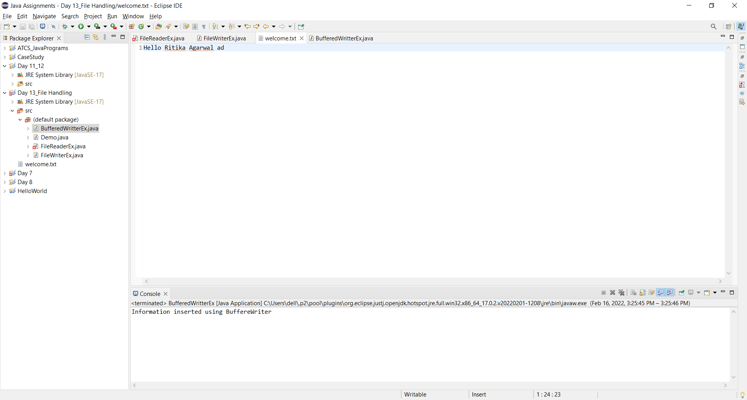

1. create a class and write the information by using Print Writer

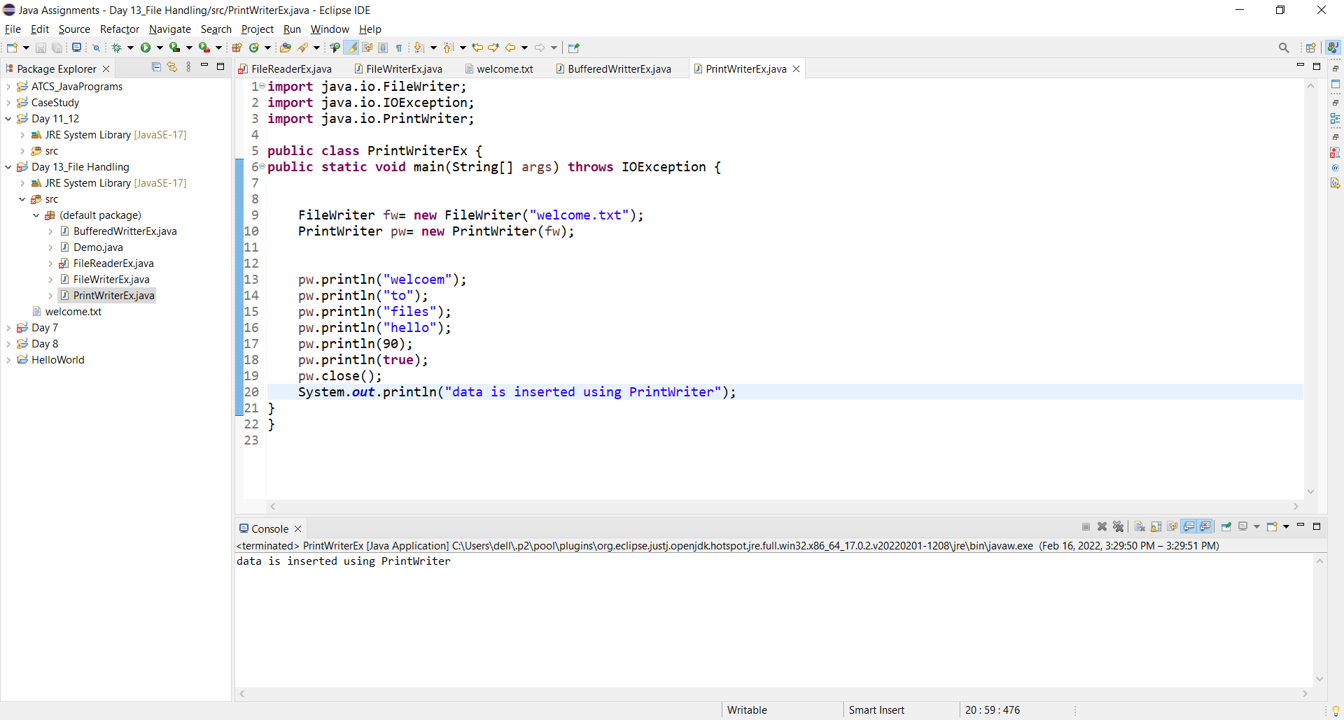

Welcome.txt file output:

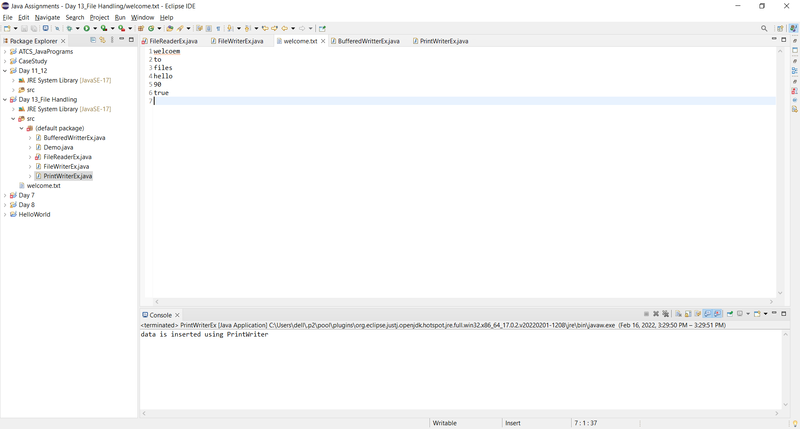

1. create a class and read the information by using File Reader.

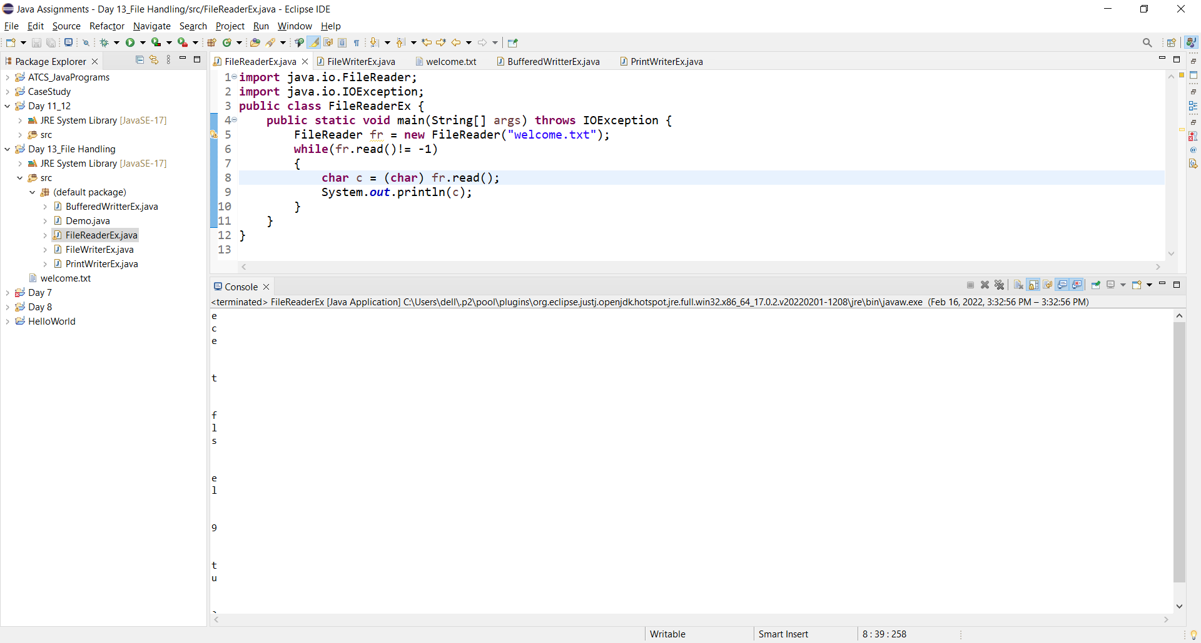

1. create a class and read the information by using Buffered Reader.

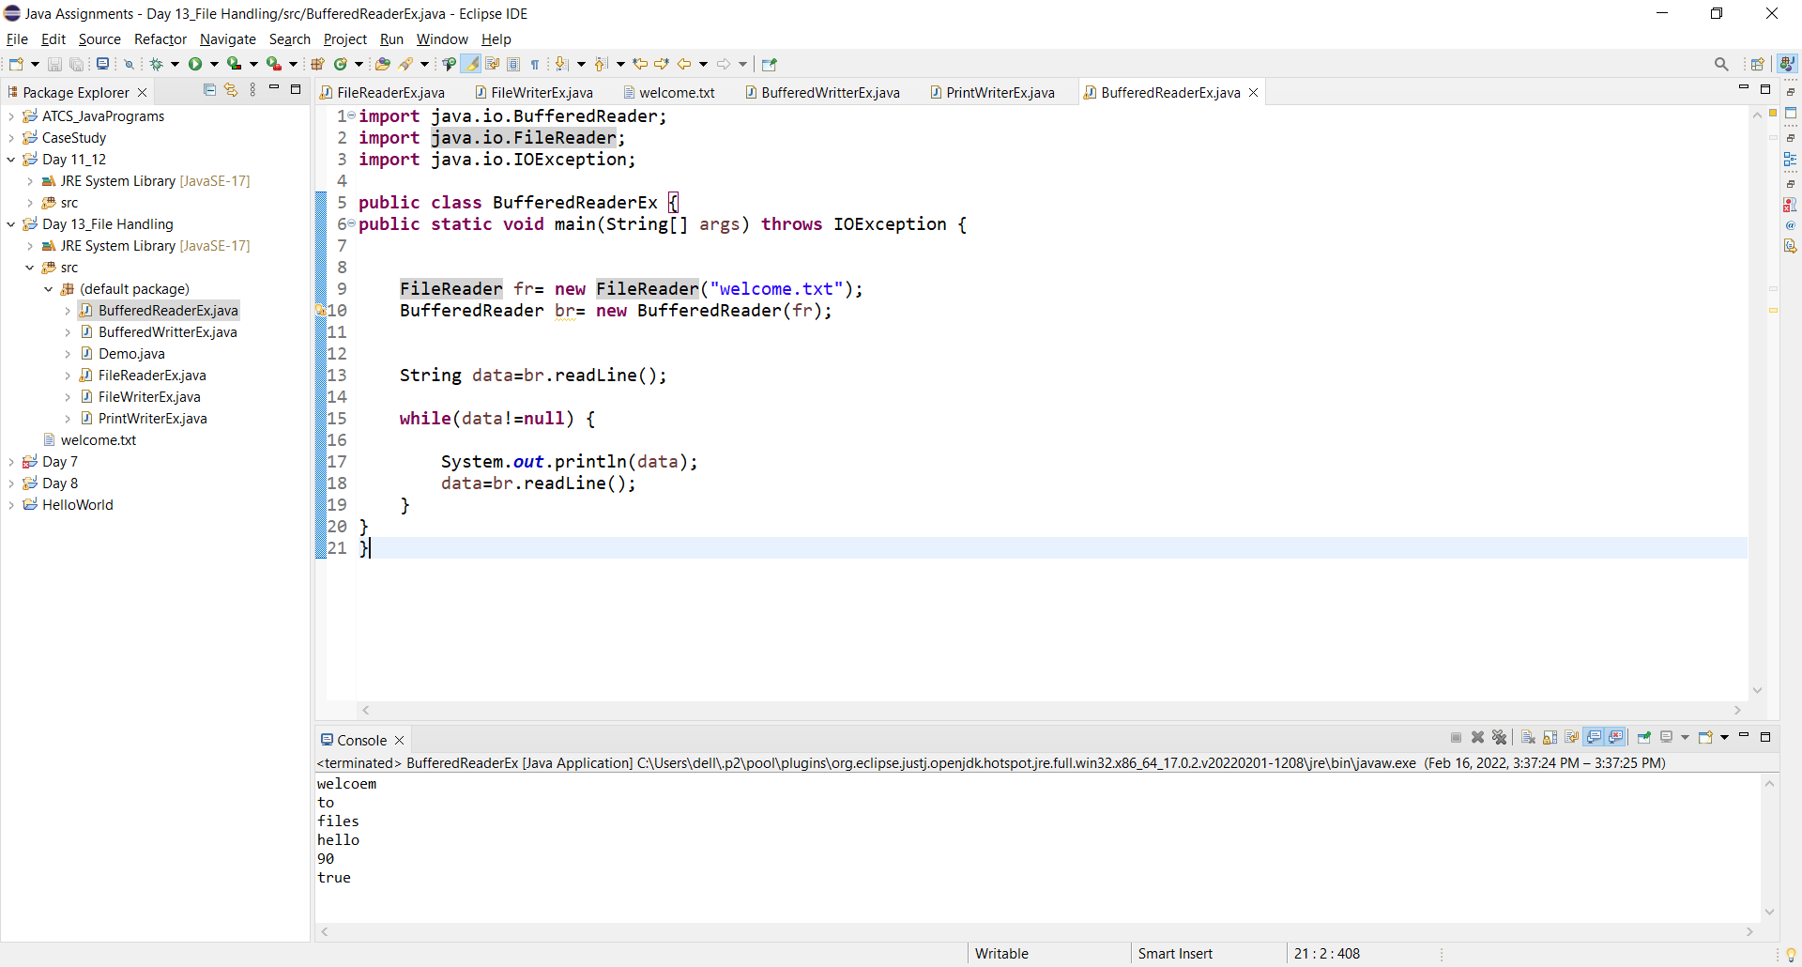

**Session 2**

1. create a class ArrayList apply without generics.

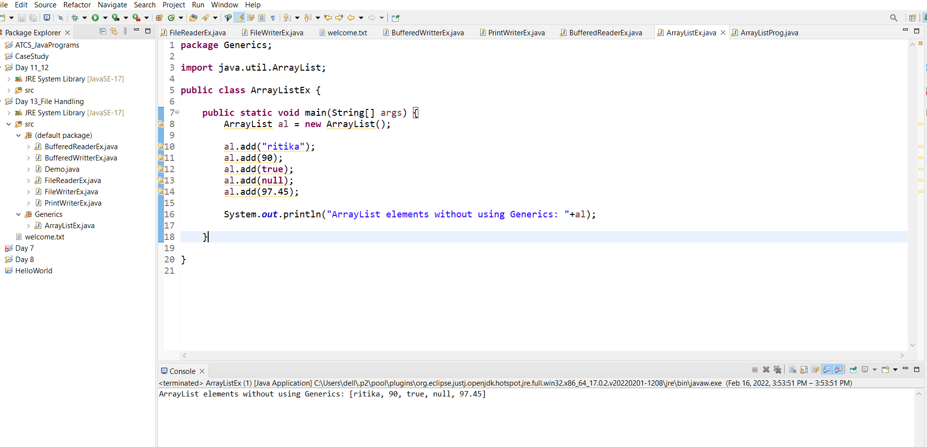

1. create a class LinkedList apply with generics.

